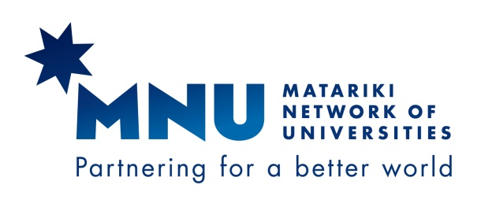

Matariki Arts & Humanities Research for the World
Tübingen Humanities Colloquium on “Languages”
9 – 12 October 2017
6 Oct 2017
Program
Monday, October 9
17:00 | Guided city tour (optional)  meeting point: Hotel Hospiz, Neckarhalde 2, Tübingen
19:15 | Dinner  Restaurant “Wurstküche”  Am Lustnauer Tor 8 (5 minutes walk from Hotel Hospiz)
Tuesday, October 10
9:00 | Joint Session  Castle of Hohentübingen, Institute for Classical Archaeology  meeting point: 8:45 Hotel Hospiz  Opening address: Prof. Dr. Monique Scheer, Vice-President (International) University of Tübingen  Short Institutional Presentations of all MNU Universities
10:00-13:00 | Academic stream  Institute for Classical Archaeology  Language Studies and Language policy at MNU universities – 7 presentations and discussion
10:30-13:30 | Library stream  University Library, Bonatzbau, Schulungsraum  Academic Libraries in Germany – Framework of Collaboration and Development - a short overview (Marianne Dörr)  11.15-11.30 coffee break  Benchmarking Session (Simon Hart / Howard Amos)  - Responses to the fourth survey (“How the Library helps researchers measure and communicate impact.”)  - Application of the self-assessment tool  Topics for the next survey
13:30 | Lunch University library
15:00-18:00 | Joint Session  University Library  Visit of the Library – short guided tour  Presentation of historical collections  Core Facility E-Science-Center / Digital Humanities Master Profile (Dr. Matthias Lang, Coordinator E-Science-Center)
19:00 | Dinner  Restaurant Museum, Wilhelmstraße 3
Wednesday, October 11
9:30-12:00 | Academic Stream:  Faculty room, Keplerstraße 2  Research presentations 1  Lorraine Wong, Otago: Sharing Estrangement: Lu Xun’s “Diary of a Madman” and its Latinized Translation  Claudia Nitschke, Durham: Contracts and Games: Goethe’s Götz von Berlichingen  Roberto Rey Agudo, Dartmouth: Assessing Gains in Short-Term Study Abroad Programs  Donato Santeramo, Queen’s: Luigi Pirandello and the Stage: Tonight We Improvise... But maybe not
Library Stream:
University Library (Bonatz-Bau)
Between Big Deals and Open Access -1-
Scholarly Communications Roadmap – results of the survey (giving a background to our discussion) (Martha Whitehead)
The big deal, tactics and strategies and the environment each partner operates in (Howard Amos)
The DEAL-Project – Status and Challenges (Frank Scholze, Head of KIT Library Karlsruhe and deputy spokesperson for the DEAL project group)
Discussion
12:00 | Lunch (Mensa Wilhelmstraße)
13:30-16:30 | Academic Stream  Faculty room, Keplerstraße 2  Research presentations – 2 -  Coco Norén, Uppsala: Research structures in the field of language in Uppsala  Alexandra Ludewig, Perth: Language Learning with Performance Techniques and Flow  Kristina Peuschel, Tübingen Teaching linguistically responsive in multilingual German Secondary Schools  Matthias Bauer, Tübingen: Interdisciplinarity in Action: the Tübingen Research Training Group 'Ambiguity: Production and Perception'  Time for meetings and discussions with research partners
Library Stream
University Library (Bonatz-Bau)
Between Big Deals and Open Access 2
Howard Amos, Jill Benn & Simon Hart Testing the assumptions of flipping subscriptions
Simon Hart Measuring the cost of institutional repositories
Susan Mehrer Open Access in the US – status and current trends
Cecilia Petersson OA-Initiatives in Sweden/Nordic Countries”
Mike Wall OA and Big Deal – Insights in UK negotiations
Discussion: Open Matariki – how to move on?

17:00 | Guided Tour Museum Schloss Hohentübingen (with the original Ice Age figures declared “UNESCO World Culture Heritage” a few weeks ago)
19:15 | Dinner  Restaurant “Schwärzlocher Hof”  Bus departure: 19:00 Hotel Hospiz
Thursday, October 12
9:00-10:00 | Academic Stream  Alte Aula, Münzgasse  Libraries Stream  University library  final internal discussions
10:00-12:00 | Joint session:  Alte Aula, Münzgasse  presentations of results, the final colloquium in Uppsala 2018, farewell
12:00 | Snack

Tübingen organizers:
Prof. Dr. Jürgen Leonhardt, Dean of Faculty of Humanities, Dept. of Classics juergen.leonhardt@uni-tuebingen.de
Mobile ++49 171 785 4869
Dr. Marianne Dörr, University Librarian marianne.doerr@uni-tuebingen.de
Mobile ++49 152 0921 4792
Tübingen Matariki Coordinator:
Dr. Karin Moser v. Filseck karin.moser@uni-tuebingen.de
Mobile ++49 171 120 8495

If there are any questions or problems, please don’t hesitate to contact us via mobile (Sunday included)!

